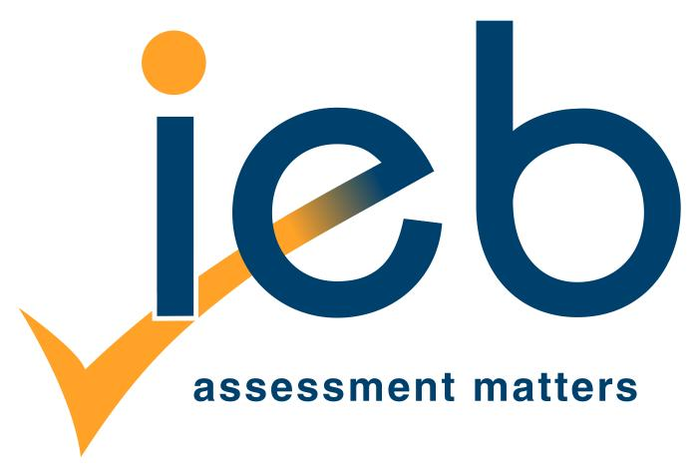
5 Anerley Road, Parktown, 2193
P O Box 875, Highlands North, 2037 Telephone: +27 11 483 9700
Facsimile: +27 11 486 2654
Email: assess@ieb.co.za
Website: www.ieb.co.za

Directors: CA Soudien (Chairman), AK Oberholzer (CEO), JW Aitchison, DP Dlamini, M Higa, PM Jackson, NT Johnstone, K König, CS Mofet-Mubu, CS Ndaba
M Pahad, J Papier, DB Wylde, N Yeld

Independent Examinations Board NPC Reg. No.1988/003512/08
NPO No. 013-388

PLACEMENT ASSESSMENTS

- IEB Placement Assessments

IEB offers placement assessments in Communications in English and Mathematical Literacy. Each learning area has two graded assessments:
- AET Levels 1 - 4 (NQF Level 1)
- NQF Levels 1 - 4

- Purpose of the placement tool

- Communications in English: competence in the language of learning and teaching is essential for success in a learning programme. While many learnership candidates are ready for training at the required level in the technical areas of a qualification, their language skills in English as the language of learning are often at a much lower level. This can cause a lot of problems in relation to dealing with learning material and acquiring new skills and knowledge in relation to unit standards. Placement results can alert the training provider to potential problems in the training process, so that necessary steps (e.g. top up training; simplification of learning materials; translation) can be taken. The tool assesses a learner’s entry readiness for study and workplace training at either the required AET or NQF 1 level, or NQF Levels 1, 2, 3 or 4. The tool does not assess across all the relevant standards, and does not result in registered credit on the NQF.

- Mathematical literacy: competence in maths literacy is often required in terms of progression through AET, and as a SAQA requirement for qualifications from NQF Levels 1-4. The placement assessment aims to assess learner understanding and application of key numeracy concepts in order to place learners in appropriate learning programmes ranging from ABET Levels 1-4 (NQF 1), or to select learners into appropriate levels for learnerships from NQF 1-4. The majority of our learners are unschooled, poorly schooled or have forgotten much of what they learned at school; the assessment therefore does not focus on assessing formal mathematical knowledge, but aims to uncover information about people’s understanding of numbers and their knowledge of how to work with numbers. The tool does not assess across all the relevant standards, and does not result in registered credit on the NQF.

- Design of the tools

Both the language and maths tools are graded instruments across the relevant levels. Sections are designed with increasing levels of difficulty. Learners are assessed and scored at a level for each skills area, and then a formula for an overall judgement is applied in order to determine the recommended level of placement.

- 2 -

- Reporting

The client will receive a report giving recommended levels for each learner. A more detailed breakdown on an individual’s strengths and weaknesses will be available at an additional fee.

- Processes

Clients will receive instructions for administering the assessments along with the assessment tools, and instructions for returning the completed assessments to the IEB. There is a minimum two-week turn-around period for clients to receive results from the time the assessments are returned to the IEB.

- Fees

Level | Cost of Placement
AET Levels 1 – 4 | R121.00 per learner per learning area
NQF Levels 1 – 4 | R217.00 per learner per learning area

The above fees include VAT

Please DETACH and complete the order form below and send to Agnes Mkandla or Sandile Buthelezi MkandlaA@ieb.co.za / buthelezis@ieb.co.za ; or by facsimile to 086 2400 450.

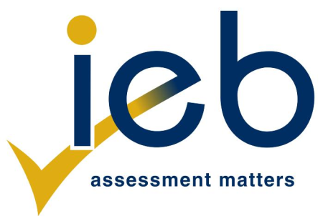

Placement Assessments: Order Form

Fax or e-mail to Agnes Mkandla/Sandile Buthelezi at: 086 2400 450 or
MkandlaA@ieb.co.za / buthelezis@ieb.co.za
Where possible, please attach a list of names of the candidates to be assessed.

Company/organisation:

VAT Registration Number
Contact person:

Contact details: | Tel:
 | Fax:
 | e-mail:
Physical Address for delivery of papers

Address and person to which invoice should be sent

AET Levels 1 - 4 (NQF Level 1)

Communications in English | Number required | Mathematical Literacy | Number required | Centre number if registered provider/ centre
NQF Levels 1 - 4

Communications in English | Number required | Mathematical Literacy | Number required | Centre number if registered provider/ centre

TERMS AND CONDITIONS
- An invoice will be issued once the order has been processed. You will be liable for full payment of the account.
- Payment must be received prior to the despatch of material.
- At least 2 weeks must be allowed for the marking and resulting process.

